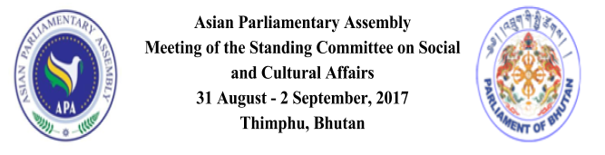
TENTATIVE PROGRAM OF WORK

Wednesday, August 30, 2017
All Day : Arrival of Delegates

1800 hrs : Reception followed by Welcome Dinner by Parliament of

Bhutan. Venue: Taj Tashi Hotel Thursday, August 31, 2017
0830 hrs | :  : | Leave hotels for Convention Center Registration of Delegates
0900 - 1000 hrs | - | Inaugural ceremony. Venue: Convention Center  Marchang Ceremony
 | -  -  -  -  - | Welcome remarks  Remarks by Secretary General, APA Secretariat Opening remarks by Representative of APA President  Opening Address by Hon’ble Speaker of Bhutan Key note address ...
1000 - 1030 hrs | - | Photo Session  Coffee Break
1030 - 1100 hrs | -  - | Standing Committee Meeting  Venue: Convention Center  Adoption of the Agenda  Election of Chairperson, Vice Chairperson and Rapporteur of
 |  | Standing Committee Meeting
 | - | Remarks by Chairperson

1100 - 1230 hrs - Meeting of APA Women Parliamentarians

1230 - 1330 hrs - Lunch break

1330 -1500 hrs - Presentation of APA Secretary General’s Report
on implementation of the present Draft Resolutions and consideration of any proposals to be presented by Member Parliaments.
- Discussion on the Draft Resolution on Measures to promote Cultural Diversity and Protect Cultural Heritage in Asia.
- Discussion on the Draft Resolution on Asian Integration through Information and Communication Technology.
1500 - 1530 hrs - Coffee Break

1600 - 1700 hrs - Continuation of presentation/discussion on Draft Resolutions:
- On Collaboration on Health Equity in Asia
- On Protection & Promotion of the Rights of Migrant Workers in Asia
1700 – 1800 hrs - Meeting of APA Energy Advisory Group

1800 hrs - End of Day 1

2000 hrs - Cultural Programme followed by Dinner hosted by Hon’ble
Speaker and Chairperson of the APA Social and Cultural Standing Committee meeting, H.E Jigme Zangpo.
Venue: Terma Linca Resort

Friday, September 1, 2017

0845 hrs - Leave hotels for Convention Center

0900 - 1030 hrs - Continuation of presentation/discussion on Draft Resolutions:
- On Asian Parliamentarians Against Corruption
- On APA Women Parliamentarians

1030 - 1100 hrs - Coffee Break

11 00 - 1230 hrs - Continuation of presentation/discussion on Draft Resolutions:

- On Promoting Inter-Faith Dialogue & Harmony among World Religions
- On Legal & Legislative Cooperation in combating the smuggling of Cultural Items in Asia
1230 - 1330 hrs - Lunch Break

1330 - 1400 hrs - Presentation and discussion on the Draft Resolutions on
Effective Cooperation in Combating Illicit Drug Trafficking in Asia
1400 - 1600 hrs - Preparation of Report by the APA Secretariat [Delegates visit
the National Assembly Hall]
1600 - 1700 hrs - Adoption of the final report of the Standing Committee Meeting
- Closing Remark by Chairman, National Council of Bhutan,
H.E. Dasho Dr. Sonam Kinga

- End of Day 2

1900 hrs - Dinner hosted by Hon’ble Chairperson of National Council, H.E
Dasho, Dr. Sonam Kinga Venue: RITH, Motithang

Saturday, September 2, 2017 Excursion (Refer separate programme)
0700 - 0800 hrs - Leave hotels for excursion

1900 hours - Dinner hosted by Hon’ble Prime Minister of Bhutan
Venue: TBC

Sunday, September 3, 2017

All Day Departure of Delegates

